ANNUAL REPORT 2024 WFW
Theme: Promoting human rights and eradicating GBV, particularly against sexual and gender minorities in Cameroon.

Prepared by: | Reviewed by: | Approved by:
MINTAKA CHRISTIAN DAMAS | TCHUENGUIA BRICE | NKWAIN HAMLET
Programme Officer | OPFAD | Executive Director
Validated by:
PEUMEUGNE Elisabeth
President of the Board of Directors

Table of contents:
I. A word from the management . 4
II. About us : 5
III. Sociopolitical context . 7
IV. Achievements in 202 4 9
This section details WFW's activities and achievements during the year 2024 , classified by area of intervention. 9
a. Support/Assistance to victims and their families 9
b. Awareness-raising, Sexual Health Education and Human Rights.................................................................................................................................................................12
c. Advocacy and field work 16
d. Capacity building 17
V. Partnerships 19
VI. Implemented projects 20
VII. Challenges Despite progress, WFW has encountered several challenges: 23
VIII. Lessons Learned 24
X. Acknowledgements 26
XI. Financial information 27

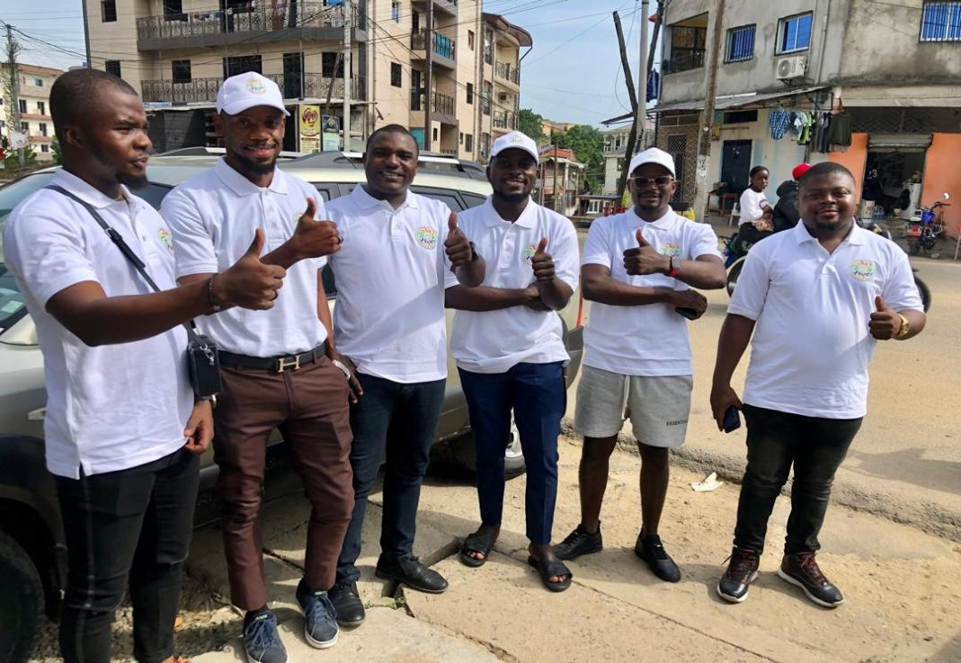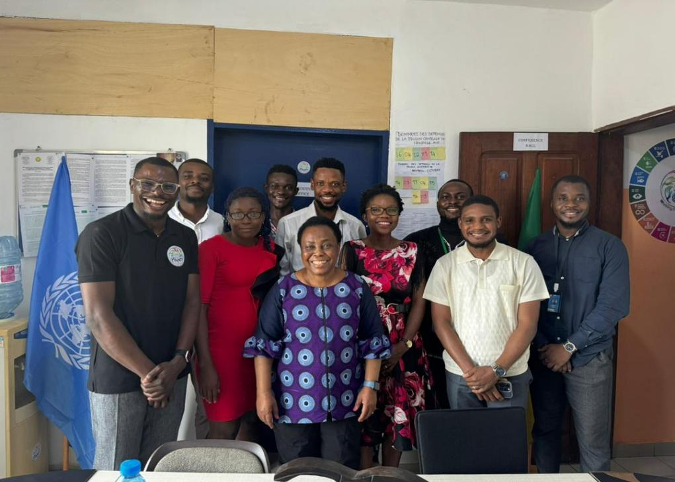

- A word from management.
Dear partners, members and supporters,
2024 has been a year of challenges and hope for Working For Our Wellbeing (WFW). In Cameroon, discrimination and violence against sexual and gender minorities persist, and our commitment to human rights is more crucial than ever. This annual report documents our hard work, our successes, but also the obstacles we have encountered. We are proud of the progress we have made thanks to your unwavering support. We reaffirm our determination to continue our mission with courage and compassion.

- About WFW.
Working For Our Wellbeing (WFW) is a non-profit organisation working to defend human rights and reduce gender-based violence in Cameroon. We focus particularly on the defence of human rights, particularly those of sexual and gender minorities, and the fight against and reduction of violence affecting sexual and gender minorities by providing assistance to survivors, victims of injustice and discrimination. To carry out its missions and achieve its objectives, WFW operates in the following regions: Littoral, South West and North West. It may also extend its activities to other regions in the interior of the country, either as part of a project or upon request. Our approach is based on
- Protecting and supporting victims of gender-based violence by providing psychological and legal assistance to sexual and gender minorities arbitrarily arrested and imprisoned, medical follow-up and direct assistance to victims of torture, a safe house that offers a safe space to people rejected because of their sexual orientation.
- Raising awareness and educating people about sexual health, in particular STI/HIV/AIDS, by offering services such as screening, psychological assistance, putting people living with HIV on ART and monitoring their progress.

- Advocacy for political and social change.
- Building the capacity of local players.
- Creating solid partnerships with civil society organisations, active and administrative forces.

- Socio-political context of Cameroon in relation to MSG.
In Cameroon, sexual and gender minorities face discriminatory laws, physical and psychological violence, stigmatisation and social exclusion. GBV, including hate crimes and torture, is frequent and often goes unpunished. MSG people and their defenders suffer abuses and violations of their rights in disregard of the Yogyakarta principles and articles 2, 3, 4 and 5 of the African Charter on Human and Peoples' Rights, which prohibits discrimination and protects all individuals from attacks on their physical and moral integrity. The State, faced with its responsibilities to respect, protect and give effect to rights, justifies its disregard for the rights of MSG by safeguarding customs, culture and so-called customary values. Resolution 275 of the African Commission on Human Rights, on the protection against violence and other human rights violations of persons on the basis of their real or assumed sexual identity or orientation, sounded like a beacon of hope for this community, which had been left to fend for itself, demonised, dehumanised and animalised in the name of religion, African law and values, the protection of the family and the protection of humanity.
The socio-political context makes our work complex, but it also strengthens our determination. Repressive legislation, combined with conservative social norms and intolerant religious interpretations, fuels a spiral of discrimination and violence.
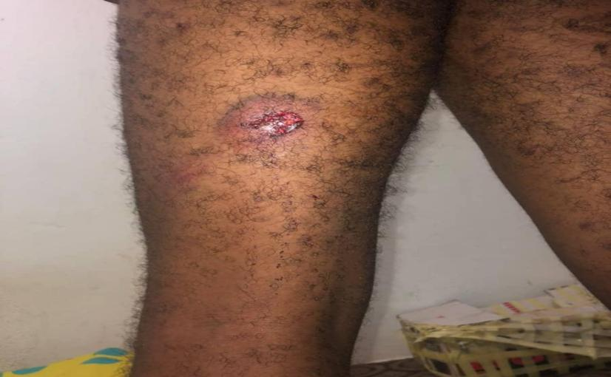 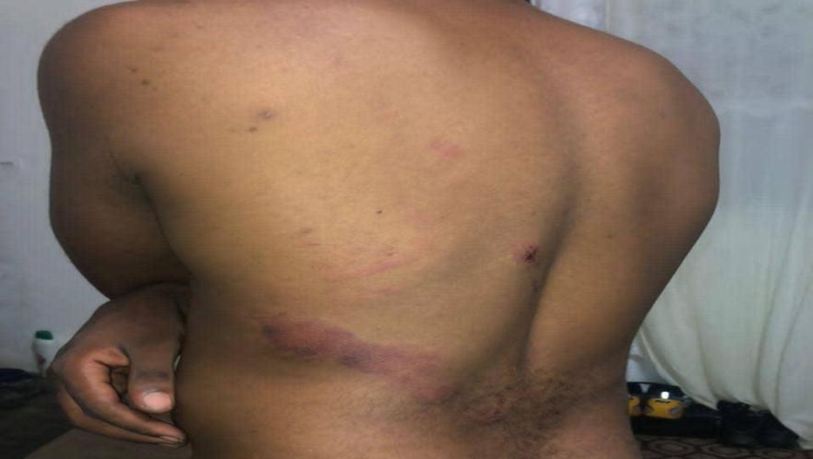

- Achievements in 2024

This section details WFW's activities and achievements during 2024, classified by area of intervention.
- Support/Assistance for victims and their families
The aim is to strengthen access to and the availability of comprehensive services, including mental health and psychosocial support, health services and any other necessary services. The aim is to ensure multi-sectoral care through appropriate, high-quality case management services. GBV case management is a structured method of assisting survivors, ensuring that they are informed of all available options, that their problems are identified, and that they benefit from coordinated follow-up. This approach is survivor-centred, treating survivors with dignity and respect, while respecting their rights.
- Psychological support: GBV can have devastating consequences on the mental health of LGBTQIA+ people, such as depression, anxiety, post-traumatic stress, suicidal ideation, and eating disorders. Psychological assistance is essential to help them overcome these difficulties. Therapy sessions help victims of GBV to rebuild their self-esteem, develop healthy coping strategies and regain control over their lives, thereby combating the internalisation of homophobia/transphobia, i.e. the internalisation of society's negative attitudes towards their identity. WFW offers essential support groups to help victims deal with trauma and improve their mental wellbeing. This can include listening, intervention and awareness-raising services.
- Medical Support: medical services are crucial for sexual and gender minorities who are victims of physical and sexual violence, as they provide essential care to treat physical injuries, prevent complications, protect sexual and reproductive health, support mental health, document forensic evidence and provide a safe and respectful environment. Access to these services is a fundamental right and a crucial step towards healing and justice. They include information on the prevention of sexually transmitted infections (STIs) and HIV, as well as access to the necessary tests and treatment.
- Legal Assistance: Legal assistance is essential for sexual and gender minorities who are victims of physical and sexual violence, arbitrary arrest and imprisonment because of their suspected sexual orientation, as it enables them to understand and assert their rights, initiate legal proceedings, obtain justice and reparation, protect themselves against discrimination, make their voices heard, obtain justice and fight discrimination. It helps to create a society that is fairer and more respectful of the rights of all people, whatever their sexual orientation or gender identity.
- Empowerment: empowerment is a multi-dimensional process that enables sexual and gender minorities who are victims of theft, scams, rejection, dismissal and other forms of discrimination to build their self-esteem, develop their skills, improve their economic situation, strengthen their resilience, promote their mental health and contribute to social change. Empowerment reduces the stress and anxiety associated with discrimination, financial difficulties and social isolation.
- Social assistance (emergency accommodation): Family rejection can often be accompanied by emotional, verbal, physical or even sexual violence. Emergency accommodation enables young MSG to be quickly removed from these dangerous environments. Family rejection is one of the main causes of homelessness among MSG. Rapid accommodation prevents these young people from ending up on the streets, where they are exposed to many dangers (violence, exploitation, health problems, assaults, murder). The shelter provides a safe, stable and supervised environment where survivors can feel protected and secure, away from the pressures and dangers of the street.

- Psycho-legal support: This aims to accompany MSG in detention/incarceration by taking into account both their psychological needs and their legal rights. This support combines psychological help to deal with the stress, trauma and emotional problems associated with imprisonment, with legal support to inform minors about their rights, legal procedures and possible remedies, and to provide them with food and clothing. 11 MSG detainees were assisted during 2024.
- Awareness-raising, Sexual Health Education and Human Rights
Too often, MSG are excluded from traditional education programmes on sexual health, relationships and human rights. This exclusion leaves them with an information vacuum that leaves them vulnerable and deprives them of the tools they need to make informed decisions. Awareness-raising and education help to deconstruct the prejudices and negative stereotypes that fuel discrimination and stigmatisation against MSG. This helps to create a more inclusive and respectful environment. By providing knowledge and skills, awareness-raising and education enable MSG to feel more confident, know themselves better and assert their identity. These programmes on sexual health, human rights, STI and HIV prevention, mental health, civic engagement, inclusion, prevention of gender-based violence and abuse are essential to improving their health and well-being, recognising different forms of violence, identifying healthy relationships and asserting their rights, and protecting themselves from violence and abuse. Awareness-raising and education encourage MSG to get involved in their communities, defend their rights and advocate for more inclusive laws and policies.
January 2024 to December 2024
PEOPLE ASSISTED: 205
Psychological | Physical | Extortion | Arrest/Incarceration | Sexual | Torture | Rejection | TOTAL
72 | 37 | 8 | 11 | 9 | 51 | 17 | 205
VBG IDENTIFIED: 264
Psychological | Physical | Economic | Arrest/ Incarceration | Sexual | Torture | Rejection | TOTAL
78 | 51 | 27 | 20 | 16 | 51 | 21 | 264

UNASSISTED PERSONS: 59
Psychological | Physical | Extortion | Arrest/Incarceration | Sexual | Torture | Rejection | TOTAL
6 | 14 | 19 | 9 | 7 | 0 | 4 | 59

TYPES OF SERVICES RECEIVED AFTER THE VIOLENCE: 349
Psychological | Medical | Legal | Shelter | Economic | TOTAL
205 | 76 | 11 | 17 | 40 | 349

Core Indicators | Achievement of annual target |  |  | Total
Core Indicators | MSM | UDI | TG | Total
Mobilisation | 1305 | 173 | 203 | 1681
HTS_ST | 319 | 34 | 45 | 398
HTS_TST | 221 | 39 | 52 | 312
HTS_TST_POS | 36 | 1 | 1 | 38
TX_NEW | 31 | 1 | 1 | 33
PREP | 22 |  |  | 22
VL_Document | 171 | 32 | 20 | 213
VL_Suppress | 171 | 32 | 20 | 213

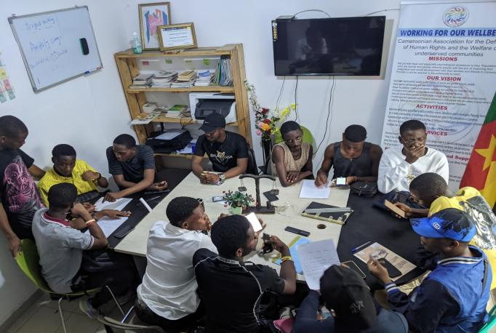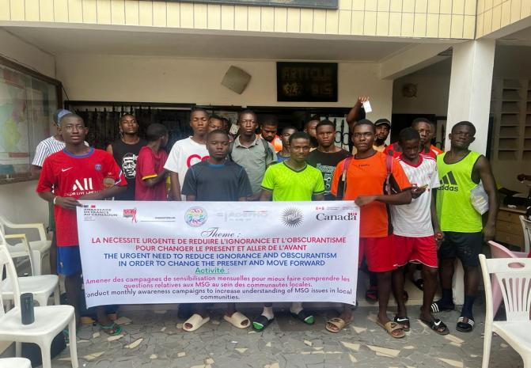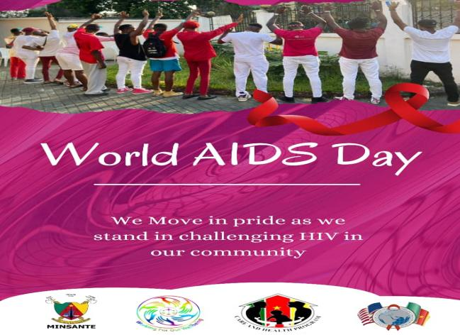

- Advocacy and field work

Advocacy and field work are essential to defend the fundamental human rights of MSG, such as the right to life, the right to liberty, the right to equality, the right to non-discrimination and the right to privacy. They are essential in combating discrimination and violence against MSG, whether based on sexual orientation, gender identity or gender expression, helping to build a more just and equitable society for all, where the rights of every person are respected and everyone can live in dignity and security. Advocacy and grassroots work encourage diversity and inclusion:
- Actions taken with local and national authorities (meetings, lobbying)
- Number of situation reports published
- Participation in conferences and forums
- Collaboration with other human rights organisations
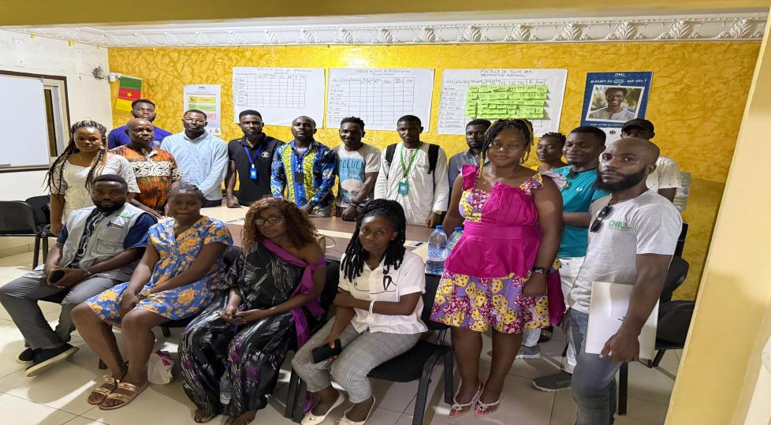

- Capacity building
The training provided to local players (community leaders, activists, associations) helps to increase the effectiveness of advocacy to strengthen the ownership and sustainability of interventions, as well as improving the safety and protection of human rights defenders working on sensitive issues to amplify the voices of survivors and advance social change. These workshops enable local actors to become more effective agents of change, to contribute more meaningfully to the development of their communities and to build a fairer and more sustainable future. The training programmes focused on the following themes: Political participation of MSG; Physical and digital security of MSG; Effects of torture, gender-based violence and gender issues; Documentation and reporting of cases of GBV.
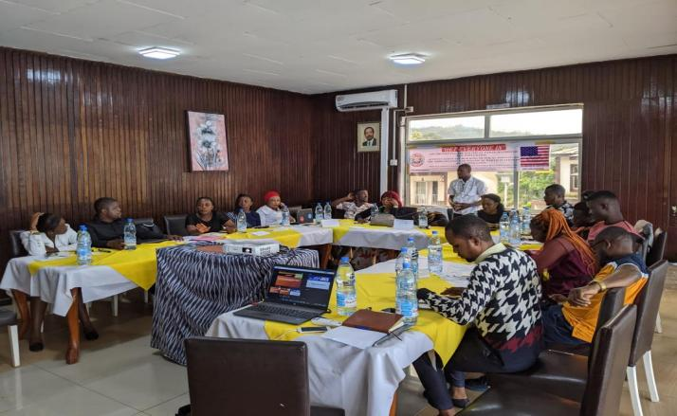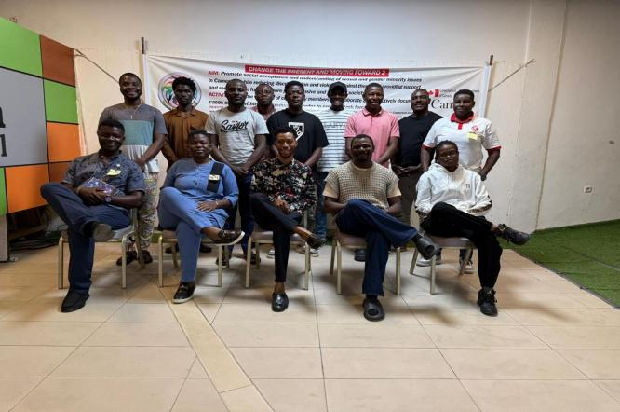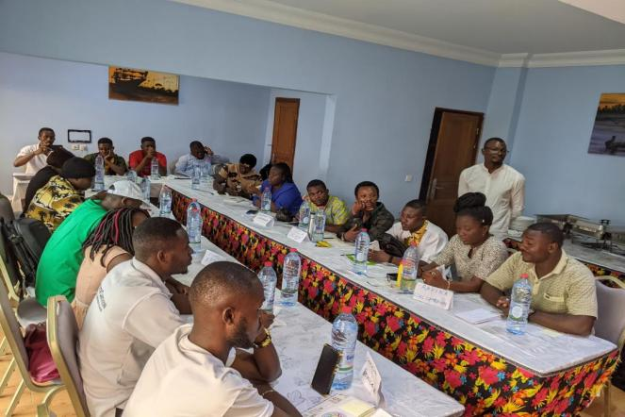
- Partnerships
Partnerships have been essential for WFW to campaign for human rights, in particular MSG. They have enabled us to amplify our impact, strengthen our legitimacy and achieve more ambitious goals in favour of equality, justice and dignity for all. However, we have worked with partners whose values and objectives are aligned with our own, and put in place monitoring and evaluation mechanisms to ensure the effectiveness of the partnerships. Through these partners, we have strengthened the impact of our messages and increased the visibility of the issues facing sexual and gender minorities, enhanced the credibility of identity-based organisations and facilitated dialogue with the authorities and institutions, provided training and technical support to help sister organisations develop their skills and improve their effectiveness, explored new approaches and strategies to promote human rights by combining different perspectives and experiences, and provided mutual support in the event of difficulties or threats, thereby building resilience and the capacity to act together.
These partners, in particular donors, civil society organisations, active forces, administrative authorities, the media, activists and human rights defenders, have led to: legal recognition of gender identity, improved access to services, reduced discrimination and gender-based violence, care for survivors of GBV, capacity-building for community players, activists and members of the community on specific issues.

- Projects implemented

Donors | Project title | Objective | Results | Implementation date
UN | PROSGM-VT024 | The aim was to guarantee equal access to healthcare, social services and civic implications for sexual and gender minorities who are victims of inhuman treatment and torture in Cameroon, while prioritising psychological, legal and medical assistance and empowerment, as well as direct support for victims of torture and gender-based violence. | Thanks to this project, we have made significant progress in supporting sexual and gender minorities (SGMs) and their families, who have endured torture, discrimination and violence. Despite the challenges, our efforts have made a real difference to the lives of many people. Key achievements include:  Assistance for victims of torture: We provided comprehensive support for 55 people from SGM communities and their families, including psychological care (individual interviews in person or by telephone) and medical/social assistance (access to healthcare and secure accommodation).  Economic empowerment: 15 people have been integrated into empowerment programmes, 5 of whom have benefited from vocational training and 10 of whom have received economic assistance to start small businesses, thereby promoting their financial independence and reintegration.  Legal assistance: We provided legal support to people arbitrarily arrested, particularly at the New Bell central prison and in Buea. This led to the release of 4 prisoners and the organisation of family visits for others. These actions have transformed lives, as the beneficiaries can testify. | 01 January -31 December 2024
US EMBASSY | My-Participation as Citizen 2 | The aim of the project is to promote respect for and political participation by sexual and gender minorities in Cameroon, and to create a more inclusive and equitable society where the rights of all individuals, regardless of their sexual orientation or gender identity, are respected and protected. It also aimed to encourage members of the community to register to vote. | Through its activities, the project enabled a better understanding of the mechanisms of the electoral process, contributing to greater transparency, rigorous documentation of irregularities and increased citizen participation, thereby strengthening democracy and the protection of human rights in the country. We have trained 45 human rights defenders and mobilised 26 civil society organisations. | September 2023 - March 2024  September 2024 - March 2025
CFLI | Changing the present and Moving Foward 2  CHANGED II | This ongoing project provided vital support to members of the sexual and gender minority community who were victims of torture and discrimination by providing legal advice and assistance, ensuring that those in need had access to essential services, support and pathways to justice to uphold their rights and ensure their well-being. It has involved the local community, raised awareness of the rights of sexual and gender minorities, challenged stereotypes and fostered a culture of acceptance and respect in the regions where we operate. | - 60 cases of GBV were documented in the 3 regions where the project was implemented;  -16 victims of arbitrary arrest and imprisonment received legal assistance.  -100% of survivors of violence received psychological assistance.  - 20 educational talks were organised to raise community awareness on a number of issues.  - 30 participants in the Littoral and South-West regions were trained to effectively and ethically document cases of GBV.  - MSG activists, leaders and community members are better equipped, informed and protected against physical and digital threats. | September 2023 - March 2024  September 2024 - March 2025
CHILL | PEPFAR | Reduce HIV and STI infections, related morbidity and mortality, and mitigate the impact of HIV on socio-economic development in Cameroon, by strengthening the technical capacity of government and civil society to implement evidence-based prevention, care and treatment services and reduce stigma among key populations in Cameroon. | See table Achievement of annual target | November 2024- March 2025
RAINBOW |  | The project aims to provide safe and temporary accommodation to MSG victims of family rejection, abandonment by their families and ex-prisoners, to provide individual or group psychosocial support to beneficiaries to help them overcome trauma and boost their self-esteem, to promote the economic empowerment of beneficiaries through income-generating activities. | - 17 MSG benefited from safe accommodation.  - Residents reported a significant improvement in their psychosocial well-being, including a reduction in anxiety, depression and feelings of isolation.  -15 beneficiaries participated in educational programmes and acquired new skills in vocational training and foreign languages.  - 05 residents have started an IGA, generating income to support themselves. | November 2024- March 2025

Challenges encountered
Despite progress, WFW has encountered several challenges:
- Limited data on GBV and SGBV in the South West and North West regions due to the socio-political and cultural situation.

- Limited access to funding

- Limited access to support networks: marginalised MSG have limited access to informal support networks, such as friends, family and the community, which makes them more isolated and vulnerable.

- Collaboration with law enforcement agencies: Collaboration with law enforcement agencies is very difficult in contexts where homosexuality is criminalised or where law enforcement agencies are homophobic and sometimes actors in violence.

- Criminalisation of homosexuality: In countries where homosexuality is criminalised, it is difficult to work openly on human rights, in particular MSG, and to provide support services to victims of GBV.

- Opposition from conservative groups: Our work to promote the well-being and development of MSG faces opposition from conservative, religious, traditional and political groups who seek to discredit us or hinder our work.

- Donors' priorities and restrictive conditions: Donors' priorities often make us ineligible, which makes it difficult to find suitable funding.
- Lessons learned
Over the course of 2024, we have learned some valuable lessons:
- The importance of active listening and personalised support.
- The need to work closely with communities, active forces and administrative authorities.
- The importance of training and capacity-building for local players.
- Adapting our strategies to the socio-political and cultural context of Cameroon
- Resilience and perseverance are essential.
- Outlook for 2024
Our priorities for 2025 are :
- Strengthen our presence in the field and expand our activities.
- Develop new programmes and innovative projects.
- Increase our funding capacity
- Strengthen our collaboration with our partners
- Intensify our advocacy for legal reform and better protection for sexual and gender minorities.
- Acknowledgements
We would like to extend our warmest thanks to our partners, funders, volunteers, members and all those who support us in our mission. Your commitment is essential to our success. 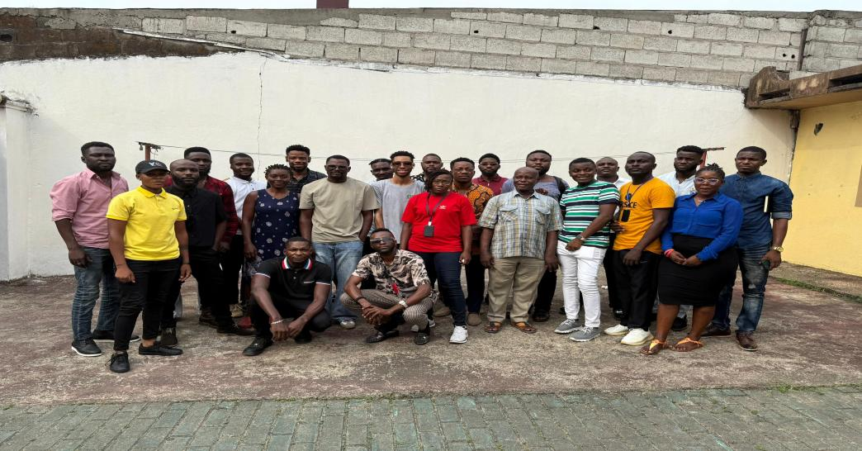

WFW 2024 Financial report
Organisation | WORKING FOR OUR WELLBEING (WFW)
Date | 31/12/2024
REVENUE
Confirm Amount in FCFA |  |  |  |  |  |  |  |  |  |  |  |  |  |  | in USD
CFLI |  |  |  |  |  |  |  |  | 2,550,000 |  |  |  |  |  | 4,264
UN |  |  |  |  |  |  |  |  | 28,300,000 |  |  |  |  |  | 47,324
US |  |  |  |  |  |  |  |  | 10,058,000 |  |  |  |  |  | 16,819
Rainbow |  |  |  |  |  |  |  |  | 7,176,000 |  |  |  |  |  | 12,000
CFLI2 |  |  |  |  |  |  |  |  | 8,500,000 |  |  |  |  |  | 14,214
US2 |  |  |  |  |  |  |  |  | 17,058,000 |  |  |  |  |  | 28,525
USAIDS/CHPCHILL |  |  |  |  |  |  |  |  | 12,229,659 |  |  |  |  |  | 20,451
Members Contribution |  |  |  |  |  |  |  |  | 4,000,000 |  |  |  |  |  | 6,689
GRAND TOTAL REVENUE |  |  |  |  |  |  |  |  | 89,871,659 |  |  |  |  |  | 150,287
- Financial information

